Write a prompt for all this situation to claude
1. Write a prompt in English to claude after understanding the whole situation if you have any doubt please feel free to ask
I need all 4 dashboard admin, user, technician and operator credentials mail and password
2. Write a prompt in English to claude after understanding the whole situation if you have any doubt please feel free to ask
changes in images of our services it must look professional
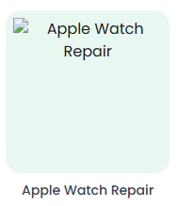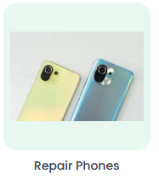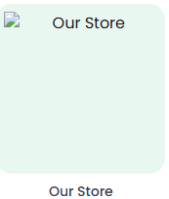

3. Write a prompt in English to claude after understanding the whole situation if you have any doubt please feel free to ask[
Change image in sell your old device it must look professional
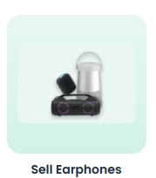

4. Write a prompt in English to claude after understanding the whole situation if you have any doubt please feel free to ask
In this portal https://www.looplic.com/service/mobile-repair i need all the functionalities of the icons must work 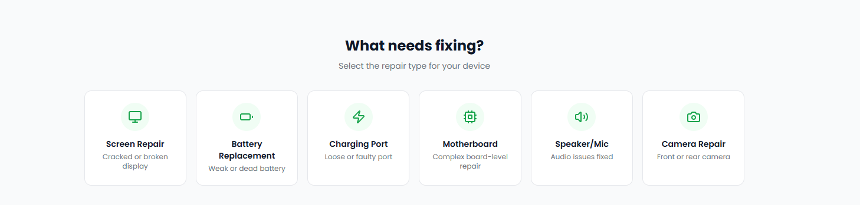

5. Write a prompt in English to claude after understanding the whole situation if you have any doubt please feel free to ask
I want to build a feature that the cctv connected with the shop where mobile is getting repair must be seen by the user in real time
mobile repair of the user can be access
cctv live repair access it personally to the user
6. Write a prompt in English to claude after understanding the whole situation if you have any doubt please feel free to ask
tracking of the service user can see the status of their order
like Order Status
Pickup Requested, etc..
7. First check is all the services are working or not, all the icons and everything is working each and every feature check it also log in/sign up there is a problem please look into that also

Write a prompt in English to claude after understanding the whole situation if you have any doubt please feel free to ask

First check is all the services are working or not, all the icons and everything is working each and every feature check it also log in/sign up there is a problem please look into that also

